ENA EREC G98/NI:2019
Type Approval and Manufacturer declaration of compliance with the requirements of G98/NI.
This form should be used when making a Type Test submission to the Energy Networks
Association (ENA).
If the Micro-generator is Fully Type Tested and already registered with the ENA Type Test Verification Report Register, the Installation Document should include the Manufacturer’s Reference Number (the Product ID), and this form does not need to be submitted.
Where the Micro-generator is not registered with the ENA Type Test Verification Report
Register this form needs to be completed and provided to the DNO, to confirm that the Microgenerator has been tested to satisfy the requirements of this EREC G98/NI.
SSEG Type reference number |  | HERF-1000
SSEG Type |  | Photovoltaic Microinverter
System Supplier name |  | Xiamen E-star Energy Co., Ltd.
Address |  | 5F, Liantai Bldg, No.43 Huli Avenue, Xiamen, China
Tel | +86 15960215407 |  | Fax |  | -
E:mail | emily@estarpower.com |  | Web site |  | -
Maximum rated capacity, use separate sheet if more than one connection option. | Connection Option
 | 0.98 | kW single phase, single, split or three phase system
 | NA | kW three phase
 | NA | kW two phases in three phase system
 | NA | kW two phases split phase system
SSEG manufacturer/supplier declaration
Manufacturer Type Test declaration. - I certify that all products supplied by the company with the above Type Tested reference number will be manufactured and tested to ensure that they perform as stated in this document, prior to shipment to site and that no site modifications are required to ensure that the product meets all the requirements of EREC G98/NI.
Signed |  | On behalf of |  | Xiamen E-star Energy Co., Ltd.
Note that testing can be done by the Manufacturer of an individual component or by an external test house.
Where parts of the testing are carried out by persons or organizations other than the
Manufacturer then that person or organization shall keep copies of all test records and results supplied to them to verify that the testing has been carried out by people with sufficient technical competency to carry out the tests.

Operating Range
 | Test 1:195.5V~47.5Hz, PF=1
HERF-1000 | 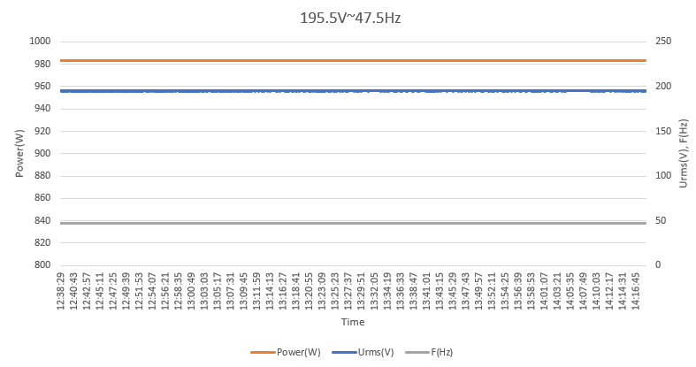
 | Test 2:253V~51.5Hz, PF=1
HERF-1000 | 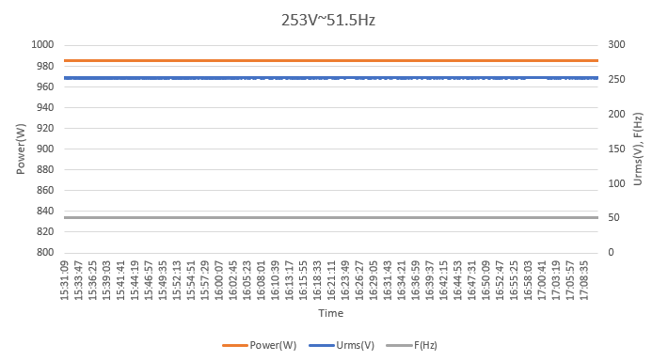
 | Test 3:253V~52Hz, PF=1
HERF-1000 | 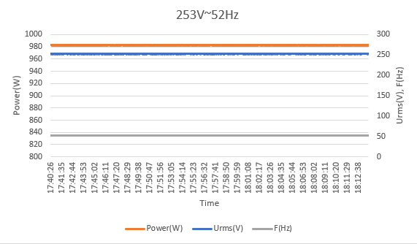

Power Quality – Harmonics: These tests should be carried out as specified in BS EN 61000-3-2.
SSEG rating per phase (rpp) |  |  | 0.98 | kW | NV=MV*3.68/rpp
Harmonic | At 45-55% of rated output |  | 100% of rated output
 | Measured  Value(MV)  in Amps | Normalized  Value (NV)  In Amps | Measured  Value(MV)  In Amps | Normalized  Value (NV)  In Amps | Limit in BS EN 61000-3-2 in Amps | Higher limit for  odd harmonics 21 and above
2 | 0.0198 | 0.0744 | 0.0410 | 0.154 | 1.080
3 | 0.0118 | 0.0443 | 0.0361 | 0.1356 | 2.300
4 | 0.0086 | 0.0323 | 0.0132 | 0.0496 | 0.430
5 | 0.0148 | 0.0556 | 0.0476 | 0.1787 | 1.140
6 | 0.0056 | 0.021 | 0.0100 | 0.0376 | 0.300
7 | 0.0211 | 0.0792 | 0.0405 | 0.1521 | 0.770
8 | 0.0050 | 0.0188 | 0.0067 | 0.0252 | 0.230
9 | 0.0155 | 0.0582 | 0.0407 | 0.1528 | 0.400
10 | 0.0036 | 0.0135 | 0.0056 | 0.021 | 0.184
11 | 0.0081 | 0.0304 | 0.0445 | 0.1671 | 0.450
12 | 0.0025 | 0.0094 | 0.0046 | 0.0173 | 0.153
13 | 0.0078 | 0.0293 | 0.0350 | 0.1314 | 0.210
14 | 0.0022 | 0.0083 | 0.0098 | 0.0368 | 0.131
15 | 0.0059 | 0.0222 | 0.0264 | 0.0991 | 0.150
16 | 0.0019 | 0.0071 | 0.0080 | 0.03 | 0.115
17 | 0.0088 | 0.033 | 0.0191 | 0.0717 | 0.132
18 | 0.0025 | 0.0094 | 0.0098 | 0.0368 | 0.102
19 | 0.0055 | 0.0207 | 0.0148 | 0.0556 | 0.118
20 | 0.0025 | 0.0094 | 0.0048 | 0.018 | 0.092
21 | 0.0067 | 0.0252 | 0.0133 | 0.0499 | 0.107
22 | 0.0016 | 0.006 | 0.0078 | 0.0293 | 0.084
23 | 0.0089 | 0.0334 | 0.0155 | 0.0582 | 0.098 | 0.147
24 | 0.0024 | 0.009 | 0.0079 | 0.0297 | 0.077
25 | 0.0067 | 0.0252 | 0.0190 | 0.0713 | 0.090 | 0.135
26 | 0.0028 | 0.0105 | 0.0092 | 0.0345 | 0.071
27 | 0.0045 | 0.0169 | 0.0184 | 0.0691 | 0.083 | 0.124
28 | 0.0004 | 0.0015 | 0.0074 | 0.0278 | 0.066
29 | 0.0042 | 0.0158 | 0.0145 | 0.0544 | 0.078 | 0.117
30 | 0.0023 | 0.0086 | 0.0110 | 0.0413 | 0.061
31 | 0.0029 | 0.0109 | 0.0129 | 0.0484 | 0.073 | 0.109
32 | 0.0022 | 0.0083 | 0.0113 | 0.0424 | 0.058
33 | 0.0072 | 0.027 | 0.0139 | 0.0522 | 0.068 | 0.102
34 | 0.0006 | 0.0023 | 0.0072 | 0.027 | 0.054
35 | 0.0084 | 0.0315 | 0.0123 | 0.0462 | 0.064 | 0.096
36 | 0.0011 | 0.0041 | 0.0078 | 0.0293 | 0.051
37 | 0.0053 | 0.0199 | 0.0085 | 0.0319 | 0.061 | 0.091
38 | 0.0019 | 0.0071 | 0.0101 | 0.0379 | 0.048
39 | 0.0070 | 0.0263 | 0.0087 | 0.0327 | 0.058 | 0.087
40 | 0.0005 | 0.0019 | 0.0100 | 0.0376 | 0.046
Note the higher limits for odd harmonics 21 and above are only allowable under certain
conditions, if these higher limits are utilised please state the exemption used as detailed in part 6.2.3.4 of BS EN 61000-3-2 in the box below.

Power Quality. Voltage fluctuations and Flicker.
 | Starting |  |  | Stopping |  |  | Running
 | dmax [%] | dc [%] | d(t) [%] | dmax [%] | dc [%] | d(t) [%] | Pst | Plt 2 hours
Measured Values at  test impedance | 0.1 | 0 | 0 | 0.1 | 0 | 0 | 0.064 | 0.064
Normalized to  standard impedance | 0.1 | 0 | 0 | 0.1 | 0 | 0 | 0.064 | 0.064
Normalized to required maximum impedance | 0.1 | 0 | 0 | 0.1 | 0 | 0 | 0.064 | 0.064
Limits set under  BS EN 61000-3-11 | 4% | 3.30% | 3.3% | 4% | 3.30% | 3.3% | 1 | 0.65
Test impedance | R | 0.4 |  | Ω | XI | 0.25 |  | Ω
Standard impedance | R | 0.24*  0.4^ |  | Ω | XI | 0.15*  0.25^ |  | Ω
Maximum impedance | R | 0.4 |  | Ω | XI | 0.25 |  | Ω
Test start date |  | 2024-01-03 |  | Test end date | 2024-01-03
Test location |  | SHANGHAI TESTING & INSPECTION INSTITUTE  FOR ELECTRICAL EQUIPMENT CO., LTD.

Power quality – DC injection: This test should be carried out in accordance with EN 50438 Annex D.3.10
Test power level | 20% | 50% | 75% | 100%
Recorded value(mA) | 0.368 | 1.57 | 2.31 | 2.62
as % of rated AC current | 0.01% | 0.04% | 0.05% | 0.06%
Limit | 0.25% | 0.25% | 0.25% | 0.25%

Power Quality – Power factor: This test shall be carried out in accordance with EN 50538 Annex D.3.4.1 but with nominal voltage -6% and +10%. Voltage to be maintained within ±1.5% of the stated level during the test.
 | 216.2V | 230V | 253V
20% of Registered  Capacity | 0.9921 | 0.9916 | 0.9903
50% of Registered  Capacity | 0.9962 | 0.9956 | 0.9948
75% of Registered  Capacity | 0.9975 | 0.9967 | 0.9959
100% of Registered  Capacity | 0.9986 | 0.9982 | 0.9971
Limit (Leading) | >0.95 | >0.95 | >0.95
Limit (Lagging) | >0.98 | >0.98 | >0.98

Protection. Frequency tests These tests should be carried out in accordance with EN 50438 Annex D.2.4 and the notes in EREC G98/NI Annex A1 A 1.3.2 (Inverter connected) or Annex A2 A.2.2.2 (Synchronous)
Function | Setting |  | Trip test |  | “No trip tests”
 | Frequency | Time delay | Frequency | Time delay | Frequency /time | Confirm  no trip
U/F | 48Hz | 0.5s | 48Hz | 0.51s | 48.2Hz/ 25s | Confirm
 |  |  |  |  | 47.8Hz/ 0.45s | Confirm
O/F | 52Hz | 1.0s | 52Hz | 1.02s | 51.8Hz/120s | Confirm
 |  |  |  |  | 52.2Hz/ 0.98s | Confirm

Protection. Voltage tests These tests should be carried out in accordance with EN 50438 Annex D.2.3 and the notes in EREC G98/NI Annex A1 A 1.3.1 (Inverter connected) or Annex A2 A.2.2.1 (Synchronous)
Function | Setting |  | Trip test |  | “No trip tests”
 | Voltage | Time delay | Voltage | Time delay | Voltage /time | Confirm  no trip
U/V stage 1 | 195.5V | 3s | 195.3V | 3.02s | 199.5V/5s | Confirm
U/V stage 2 | 138V | 2s | 137.8V | 2.02s | 142V/2.5s | Confirm
 |  |  |  |  | 134V/1.98s | Confirm
O/V stage 1 | 253V | 0.5s | 252.6V | 0.51s | 249V/5.0s | Confirm
 |  |  |  |  | 257V/0.45s | Confirm
Note for Voltage tests the Voltage required to trip is the setting ±3.45 V. The time delay can be measured at a larger deviation than the minimum required to operate the protection. The No trip tests need to be carried out at the setting ±4 V and for the relevant times as shown in the table above to ensure that the protection will not trip in error.

Protection. Loss of Mains test. For PV Inverters shall be tested in accordance with BS EN62116. Other Inverters should be tested in accordance with EN 50438 Annex D.2.5 at 10%,55% and 100% of rated power.
Note: Inverter tested according to BS EN 62116.
Test Power and  imbalance | 33%  -5% Q  Test 22 | 66%  -5% Q  Test 12 | 100%  -5% P  Test 5 | 33%  +5% Q  Test 31 | 66%  +5% Q  Test 21 | 100%  +5% P  Test 10
Trip time. Limit is 0.5s | 91.2ms | 113.8ms | 160.4ms | 91.3ms | 113.6ms | 172.1ms

Protection. Frequency change, Stability test This test should be carried out in
accordance with EREC G98/NI Annex A1 A 1.3.5 (Inverter connected) or Annex A2 A.2.2.5 (Synchronous).
 | Start Frequency | Change | End Frequency | Confirm no trip
Positive Vector Shift | 49.5Hz | +50 degrees |  | Confirm
Negative Vector Shift | 50.5Hz | - 50degrees |  | Confirm
Protection – Frequency change, RoCoF Stability test: The requirement is specified in section 11.3, test procedure in Annex A 1.3.5 (Inverter connected) or Annex A2 A.2.2.5 (Synchronous).
 | Ramp range | Test frequency ramp: | Test Duration | Confirm no trip
Positive Frequency drift | 49Hz to 51Hz | +0.95Hz/sec | 2.1s | Confirm
Negative Frequency drift | 51Hz to 49Hz | -0.95Hz/sec | 2.1s | Confirm

Protection – Limited Frequency Sensitive Mode – Overfrequency test: This test should be carried out in accordance with EN 50438 Annex D.3.3 Power response to over- frequency. The test should be carried out using the specific threshold frequency of 50.2 Hz and droop of 4%.
Test sequence at Registered  Capacity >80% | Measured  Active Power  Output (W) | Frequency (Hz) | Primary Power Source | Active Power  Gradient
Step a) 50.00 Hz ±0.01Hz | 981.77 | 50 |  | -
Step b) 50.25 Hz ±0.05Hz | 970.83 | 50.25 |  | -
Step c) 50.70 Hz ±0.10Hz | 752.92 | 50.7 |  | -
Step d) 51.15 Hz ±0.05 Hz | 528.52 | 51.15 |  | -
Step e) 50.70 Hz ±0.10Hz | 752.38 | 50.7 |  | -
Step f) 50.25 Hz ±0.05Hz | 970.29 | 50.25 |  | -
Step g) 50.00 Hz ±0.10Hz | 981.27 | 50 |  | -
Test sequence at Registered Capacity  40% - 60% | Measured  Active Power  Output (W) | Frequency (Hz) | Primary Power Source | Active Power  Gradient
Step a) 50.00 Hz ±0.01Hz | 496.49 | 50 |  | -
Step b) 50.25 Hz ±0.05Hz | 479.37 | 50.25 |  | -
Step c) 50.70 Hz ±0.10Hz | 255.50 | 50.7 |  | -
Step d) 51.15 Hz ±0.05 Hz | 31.34 | 51.15 |  | -
Step e) 50.70 Hz ±0.10Hz | 256.15 | 50.7 |  | -
Step f) 50.25 Hz ±0.05Hz | 480.25 | 50.25 |  | -
Step g) 50.00 Hz ±0.10Hz | 496.64 | 50 |  | -
Steps as defined in EN 50438

Protection – Power output with falling frequency test: This test should be carried out in accordance with EN 50438 Annex D.3.2 active power feed -in at under-frequency.
Test sequence | Measured Active Power Output (W) | Frequency (Hz) | Primary power source
Test a) 50 Hz ± 0.01 Hz | 981.5 | 50 | DC supply
Test b) Point between 49.5  Hz and 49.6 Hz | 981.2 | 49.55 | DC supply
Test c) Point between 47.5  Hz and 47.6 Hz | 980.7 | 47.55 | DC supply
NOTE: The operating point in Test (b) and (c) shall be maintained for at least 5 minutes

Protection. Re-connection timer.
Test should prove that the reconnection sequence starts after a minimum delay of 20 s for restoration of voltage and frequency to within the stage 1 settings of Table 2.
Time delay setting | Measured  delay | No reconnection when voltage or frequency is brought to just outside stage 1 limits of table 1.
60s | 90.1s | At 257V | At 191.5V | At 47.9Hz | At 52.1Hz
Confirmation that the SSEG does not re-connect. |  | Confirm | Confirm | Confirm | Confirm

Fault level contribution. The requirement is specified in section 5.7, test procedure in Annex A or B 1.4.6
For a directly coupled SSEG |  |  | For a Inverter SSEG
Parameter | Symbol | Value | Time after fault | Volts | Amps
Peak Short Circuit current | ip | N/A | 20ms | 18.98V | 0.464A
Initial Value of aperiodic current | A | N/A | 100ms | 11.63V | 0.216A
Initial symmetrical short-circuit current* | Ik | N/A | 250ms | 9.37V | 0.105A
Decaying (aperiodic) component of short circuit current* | iDC | N/A | 500ms | 5.37V | 0.082A
Reactance/Resistance Ratio of source* | X/R | N/A | Time to trip | 0.005s | (in seconds)

Self-Monitoring solid state switching :No specified test requirements. Refer to EREC G98/NI Annex A1 A 1.4.6 (Inverter connected). | Yes/or NA
It has been verified that in the event of the solid state switching device failing to disconnect the Micro-generator, the voltage on the output side of the switching device is reduced to a value below 50 V within 0.5 s. | N/A

Logic interface (input port) | Yes/or NA
Confirm that an input port is provided and can be used to shut down the module. | Yes

Additional comments

